How to add a customized menu to Blender

1. Get into the scripting panel, click “scripting”

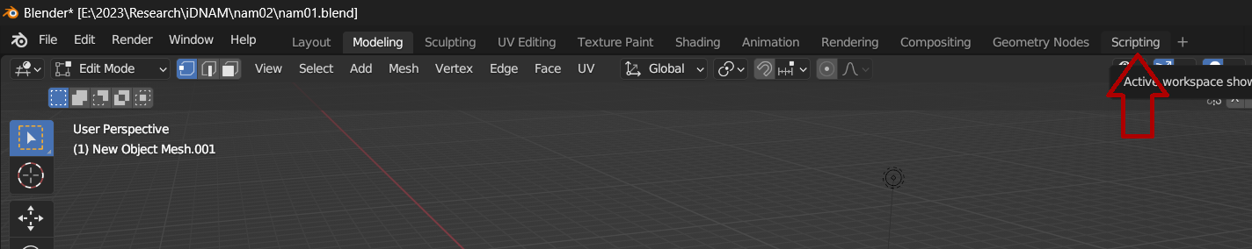

1. Get a code template for add on object: Click “Templates” > Choose “Python” > “Addon Add Object”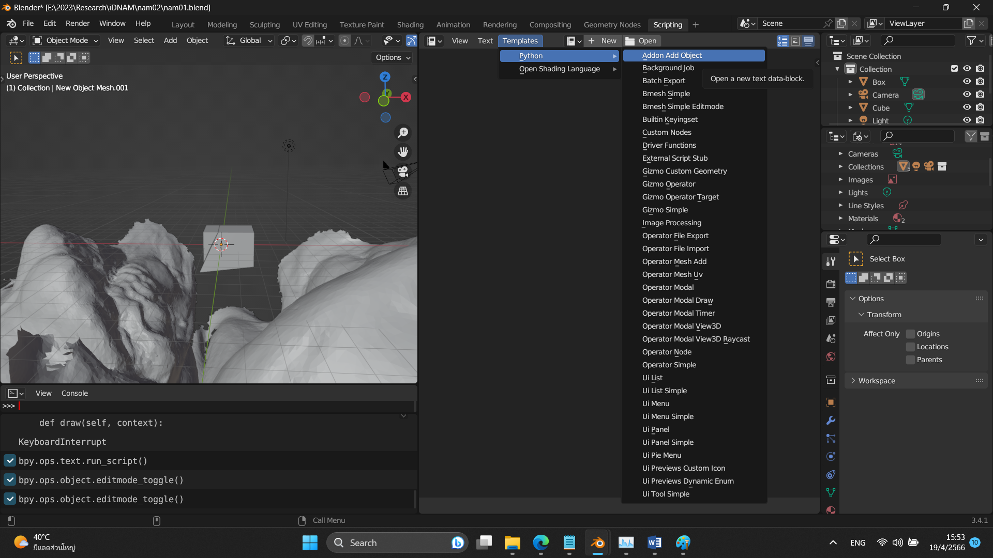
2. Edit the code template to suit our need

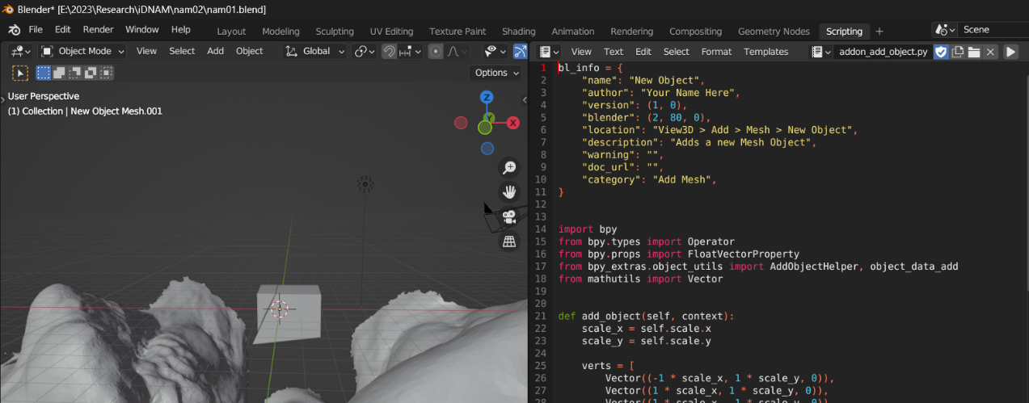

E.g, try edit the menu name to “Do whatever, e.g., Add Object”

|  |
| --- |
| # Registration  def add_object_button(self, context):  self.layout.operator(  OBJECT_OT_add_object.bl_idname,  text="Do whatever, e.g., Add Object",  icon='PLUGIN') |

1. Run.

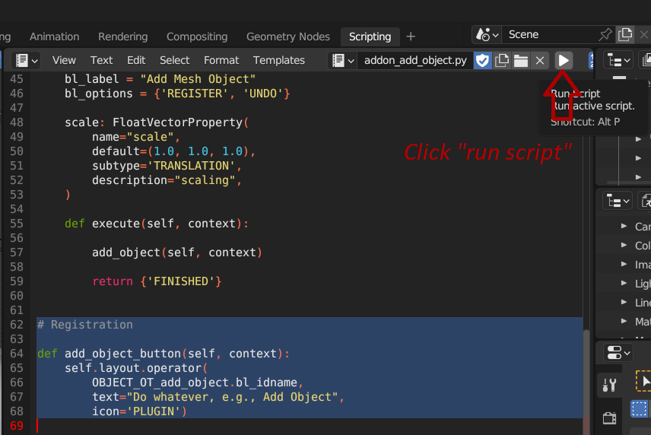

1. Done! Now we have a new menu item ready for service.

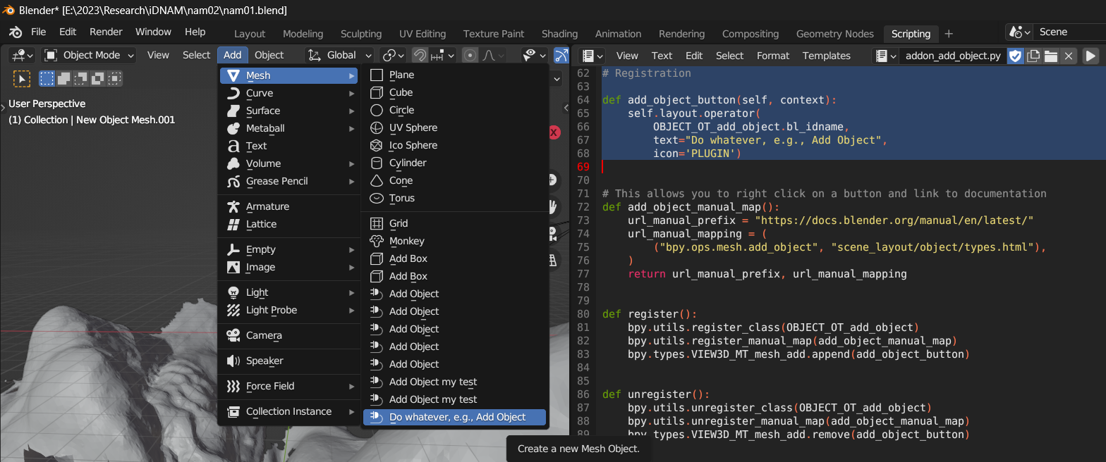

If clicked, we will see a new object (a boring flat rectangle centered at the origin) is added.